

**INSERT YOUR**

**LOGO HERE**

Shop Name

Address Line 1

Address Line 2

Phone Number

www.webaddress.com

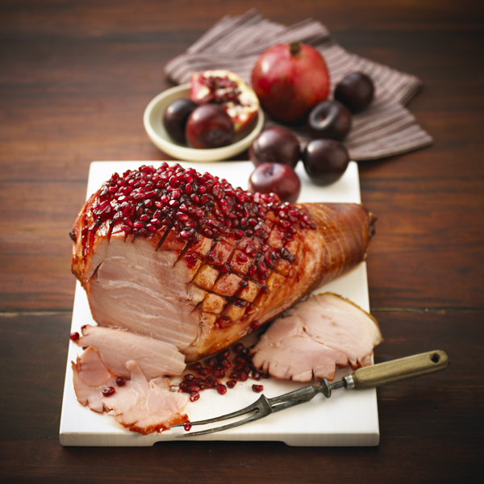**[](http://www.porkbutchers.com.au/)**

1. Remove ham from the packaging and remove the rind carefully.  Score the surface into a diamond pattern.

2. Place the ham into a deep baking dish and place in the pre-heated oven at 180°C for 20 minutes.

3. In a medium saucepan place the juice, sugar, plum jam and mixed spice. Bring to the boil stirring.  Allow to simmer until liquid has reduced by half.

4. Remove ham and pour over half the glaze.  Return the ham to the oven and cook for a further 40 minutes basting with glaze frequently.

5. Remove ham from oven and transfer to a serving dish.

6. Decorate the ham with pomegranate seeds.

7. Serve warm with vegetables or salad.

**Notes:** store leftover ham in a ham bag soaked in boiling water and 2

Tablespoons of vinegar, then squeezed dry. This process needs to be

repeated every 3 days to keep ham fresh.

1 x 2 - 3kg Australian boneless leg of ham

**Glaze:**1 cup pomegranate or black current juice  
1 cup sugar  
1 cup plum jam  
1/2 tsp mixed spice  
1 cup pomegranate seeds

**Ingredients:**

*For hundreds of pork recipes visit www.pork.com.au*

**Preparation Time** 10 minutes

**Cooking Time** 1 hour

**Serves** 8 - 10

**Cooking Instructions:**

**Baked Ham with Plum and Pomegranate Glaze**

**Method**



**INSERT YOUR**

**LOGO HERE**

Shop Name

Address Line 1

Address Line 2

Phone Number

www.webaddress.com

**[](http://www.porkbutchers.com.au/)**

1. Remove ham from the packaging and remove the rind carefully.  Score the surface into a diamond pattern.

2. Place the ham into a deep baking dish and place in the pre-heated oven at 180°C for 20 minutes.

3. In a medium saucepan place the juice, sugar, plum jam and mixed spice. Bring to the boil stirring.  Allow to simmer until liquid has reduced by half.

4. Remove ham and pour over half the glaze.  Return the ham to the oven and cook for a further 40 minutes basting with glaze frequently.

5. Remove ham from oven and transfer to a serving dish.

6. Decorate the ham with pomegranate seeds.

7. Serve warm with vegetables or salad.

**Notes:** store leftover ham in a ham bag soaked in boiling water and 2

Tablespoons of vinegar, then squeezed dry. This process needs to be

repeated every 3 days to keep ham fresh.

1 x 2 - 3kg Australian boneless leg of ham

**Glaze:**1 cup pomegranate or black current juice  
1 cup sugar  
1 cup plum jam  
1/2 tsp mixed spice  
1 cup pomegranate seeds

**Ingredients:**

*For hundreds of pork recipes visit www.pork.com.au*

**Preparation Time** 10 minutes

**Cooking Time** 1 hour

**Serves** 8 - 10

**Cooking Instructions:**

**Baked Ham with Plum and Pomegranate Glaze**

**Method**