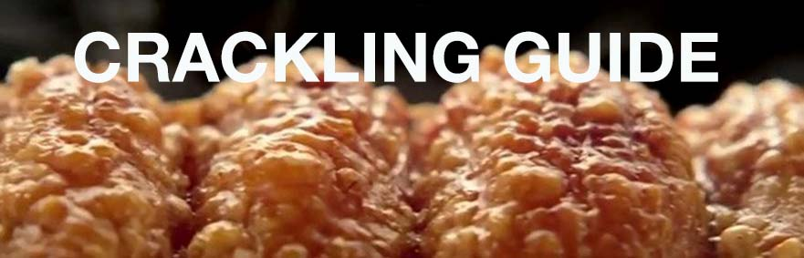

**Crackling Tip:** One of the most important tricks to the perfect crackling, is to get the rind as dry as possible before the cooking process.

1. Remove roast from packaging and pat dry with paper towel.  With a small sharp knife, deeply score the rind at 1cm intervals, being careful to not cut into the meat.  If time allows, leave the scored roast uncovered in the fridge for 1 hour, or ideally overnight.  This process further dries the rind and aids the crackling process.

2. When you're ready to cook, put your pork on a wire rack in the sink and pour a jug of boiling water over the rind. Pat dry thoroughly with paper towel.

3. Rub the roast with 1 tbsp. of vegetable oil and half a tbsp. of salt (more if you like salty crackling), making sure the oil and salt penetrate the scores.

4. Place the roast on a wire rack inside a baking tray and cook at 240°C (max 250°C conventional) until the rind crackles, up to 50 minutes.  If the roast is over 2kg, take 10 minutes off this initial crackling time.

5. Turn the oven down to 180°C and cook for 30 - 35 minutes per kg, depending on how well you like your roast cooked.

6. Once cooked, let the roast rest for 10 minutes before slicing.

**Note:** to achieve great crackling, getting the oven temperature correct is critical. We recommend the use of an "oven thermometer" to verify that the stated oven temperature is accurate.

For the Crispiest Crackling, you need:

*For hundreds of pork recipes visit www.pork.com.au*