

**INSERT YOUR**

**LOGO HERE**

Shop Name

Address Line 1

Address Line 2

Phone Number

www.webaddress.com

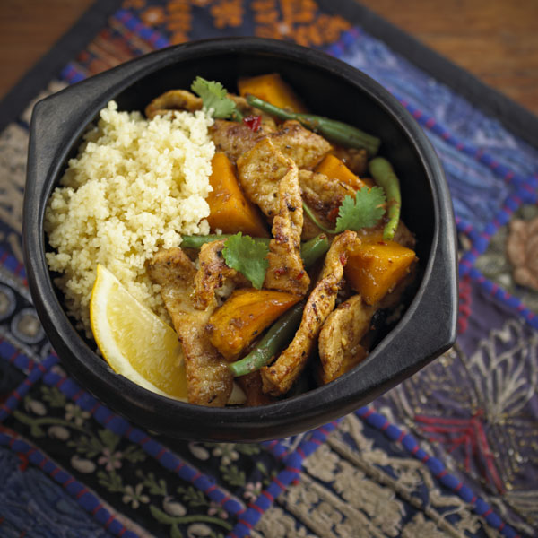**[](http://www.porkbutchers.com.au/)**

**Moroccan Spiced Pork**

**Method**

**Ingredients:**

500 g lean pork strips  
2 tblsp oil  
1 tsp chilli paste  
30 g Moroccan dukkah  
200 g pumpkin, peeled and cubed  
2 tsp ginger, grated  
150 g baby green beans  
¼ cup water  
¼ cup coriander leaves to garnish  
Wedges of lemon  
Couscous to serve

1. Place the pork strips into a medium bowl and toss together with 1 tablespoon of oil and chilli paste, coating well.

2. Sprinkle over the dukkah and coat well.

3. Heat the remaining oil in a large frying pan or wok over a medium high heat and brown pork strips well a little at a time. Remove and set aside.

4. Add the pumpkin, ginger, baby beans and water to the pan and cook covered for 10 minutes. Return the pork to the pan and continue to cook for a further 10 minutes.

5. Garnished with coriander leaves and serve hot with couscous and

lemon wedges.

**Notes:** there are several kinds of dukkah available –

pistachio, macadamia or cashew nut seasoned with Turkish spices.

*For hundreds of pork recipes visit www.pork.com.au*

**Preparation Time** 10 minutes

**Cooking Time** 15 minutes

**Serves** 4

**Cooking Instructions:**



**INSERT YOUR**

**LOGO HERE**

Shop Name

Address Line 1

Address Line 2

Phone Number

www.webaddress.com

**[](http://www.porkbutchers.com.au/)**

**Moroccan Spiced Pork**

**Method**

**Ingredients:**

500 g lean pork strips  
2 tblsp oil  
1 tsp chilli paste  
30 g Moroccan dukkah  
200 g pumpkin, peeled and cubed  
2 tsp ginger, grated  
150 g baby green beans  
¼ cup water  
¼ cup coriander leaves to garnish  
Wedges of lemon  
Couscous to serve

1. Place the pork strips into a medium bowl and toss together with 1 tablespoon of oil and chilli paste, coating well.

2. Sprinkle over the dukkah and coat well.

3. Heat the remaining oil in a large frying pan or wok over a medium high heat and brown pork strips well a little at a time. Remove and set aside.

4. Add the pumpkin, ginger, baby beans and water to the pan and cook covered for 10 minutes. Return the pork to the pan and continue to cook for a further 10 minutes.

5. Garnished with coriander leaves and serve hot with couscous and

lemon wedges.

**Notes:** there are several kinds of dukkah available –

pistachio, macadamia or cashew nut seasoned with Turkish spices.

*For hundreds of pork recipes visit www.pork.com.au*

**Preparation Time** 10 minutes

**Cooking Time** 15 minutes

**Serves** 4

**Cooking Instructions:**